**Cloning a Repository in KIE Workbench**

Git Repository URLS

Mainet processes repository - <https://github.com/abmindiarepomanager/mainet-workflow.git>

Mainet rule repository - <https://github.com/abmindiarepomanager/abm-kie-repo.git>

*Important: Note that only users with the admin role can clone repositories.*

1. Login to KIE Workbench  [[protocol]://[host]:[port]/kie-wb/kie-wb.jsp](http://192.168.100.243:8090/kie-wb/kie-wb.jsp)
2. In KIE Workbench, go to **Authoring → Administration**.
3. On the perspective menu, choose **Repositories → Clone repository**.
4. The Clone Repository pop-up window is displayed

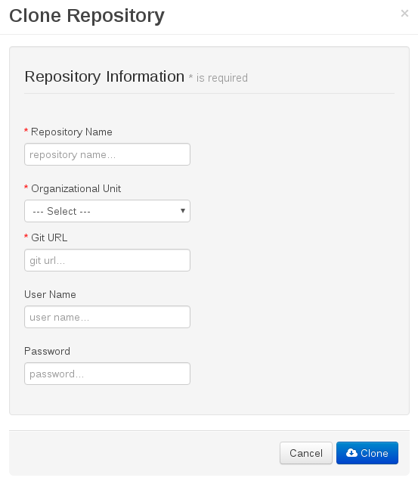

1. In the Clone Repository dialog window, enter the repository details:
   1. Enter the Repository Name to be used as the repository identifier in the Asset repository and select the Organizational Unit it should be added to.
   2. Enter the URL of the Git repository:

* for a local repository, use file:///PATH_TO_REPOSITORY/REPOSITORY_NAME;
* for a remote or preexisting repository, use https://github.com/USERNAME/REPOSITORY_NAME.git or git://HOST_NAME/REPOSITORY_NAME.
  1. If applicable, enter the **User Name** and **Password** of your Git account to be used for authentication.

1. Click **Clone**.
2. A confirmation prompt with the notification that the repository was created successfully is displayed. After clicking Ok, the repository is being indexed. Some workbench features may be unavailable until indexing has completed.
3. The cloned repository can be viewed either in the File Explorer or Project Explorer.

The cloned repository can be viewed either in the File Explorer or Project Explorer.

***Important****: It is important to use the HTTPS or Git protocol instead of a SCP-style SSH URL. KIE Workbench does not support the basic SSH URL and fails with Invalid URL format. The file protocol is only supported for READ operations. WRITE operations are not supported.*

**Project Dependencies**

* **Mainet-brms**: All projects of this repository are completely independent project and can be deployed in any order.
* **Mainet-workflow:**
  1. Project ‘common’ is a kie project focused on all aspects of reusable Java components.
  2. All project in mainet-workflow using common project as their maven dependency.
  3. In order to validate and deploy all projects successfully, common project must be deployed first.

**Build and Deployment**

To make processes/rules available for execution, you need to successfully build and deploy it first. To do so, open the selected project (in the project authoring page) and click Build & Deploy. Repeat same steps for each project.

1. Go to **Authoring -> Project authoring**

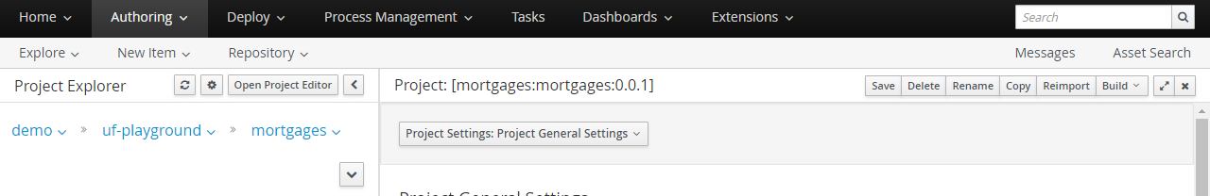

1. Click on **Open Project Editor**
2. **Build -> Build & Deploy**

